**Unix Commands**

**Pwd**: Shows the current working files.

**Mkdir**: Will create the directory.

**Ls**: List all the files.

**Ls –a**: lists the files and also the hidden files.

**Ls –l**: List the contents with the property.

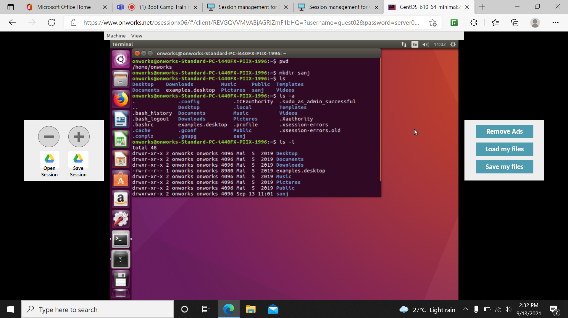

**Man**: it is the manual page.

**Cd**: change directory.

**Vi**: to create a file.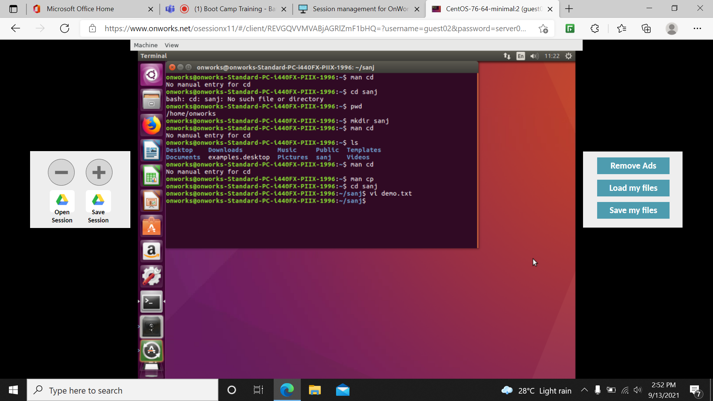

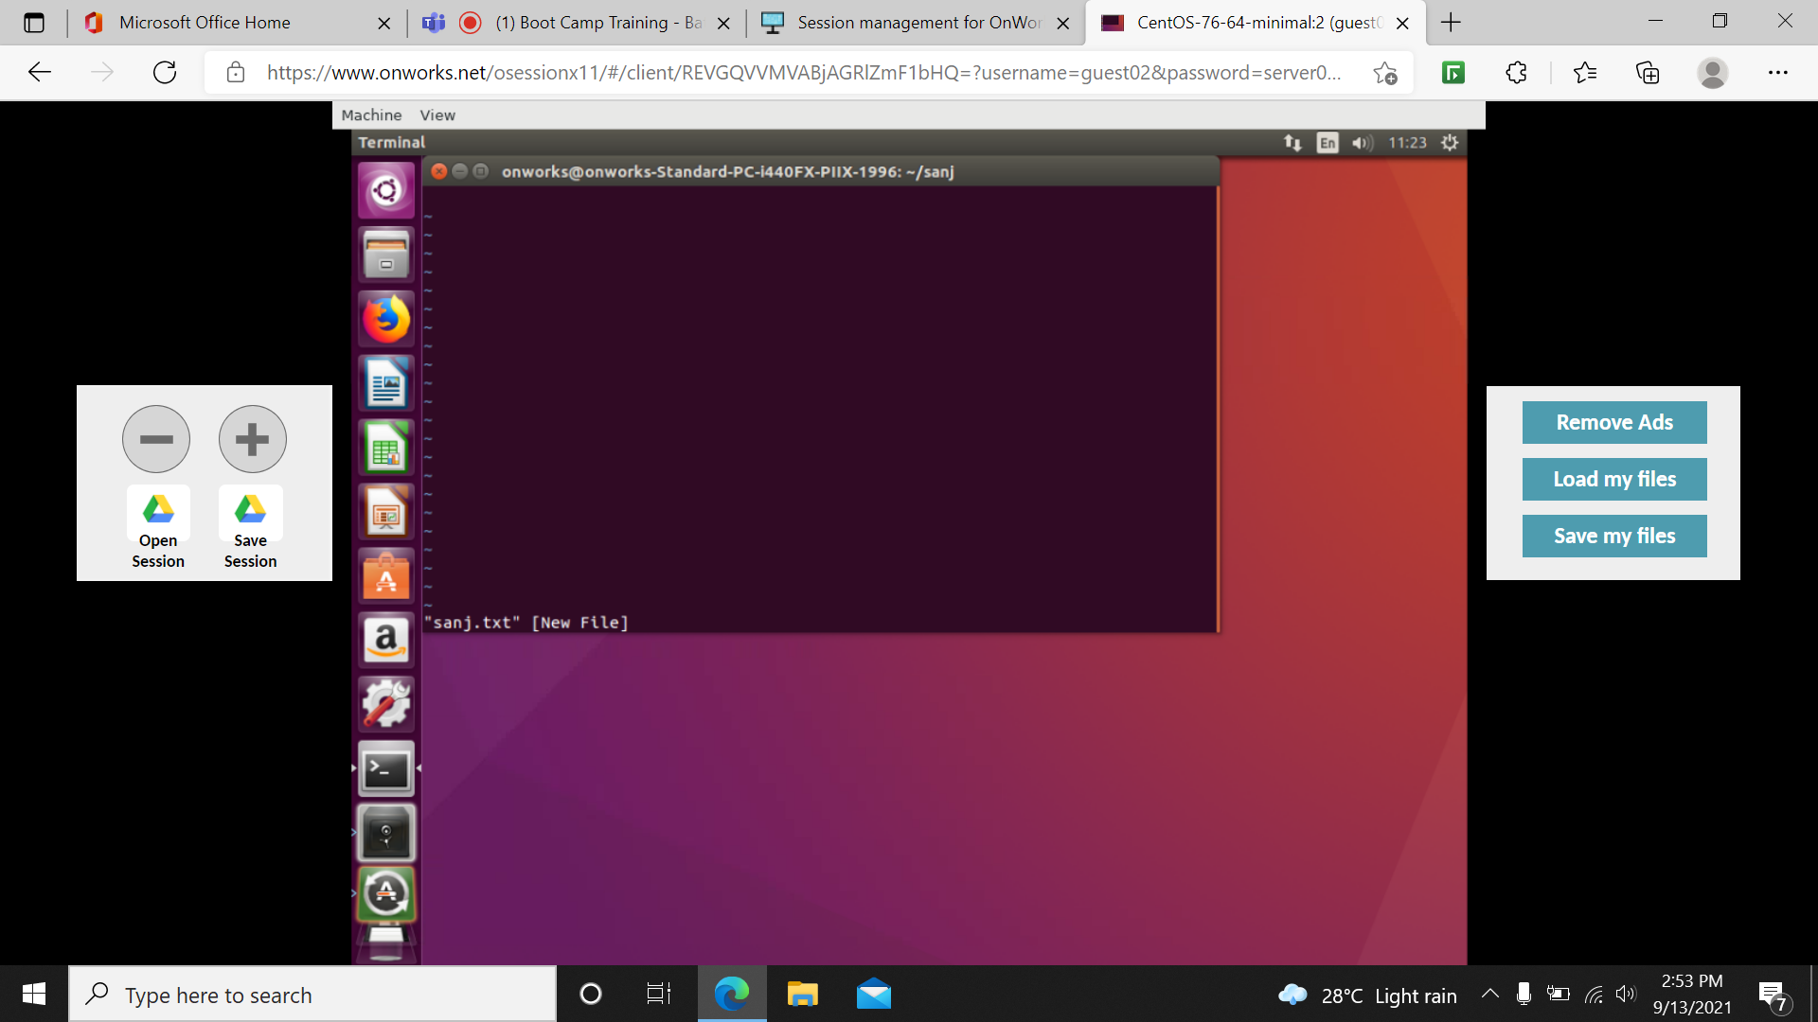

**:wq**: is used to quit from the page.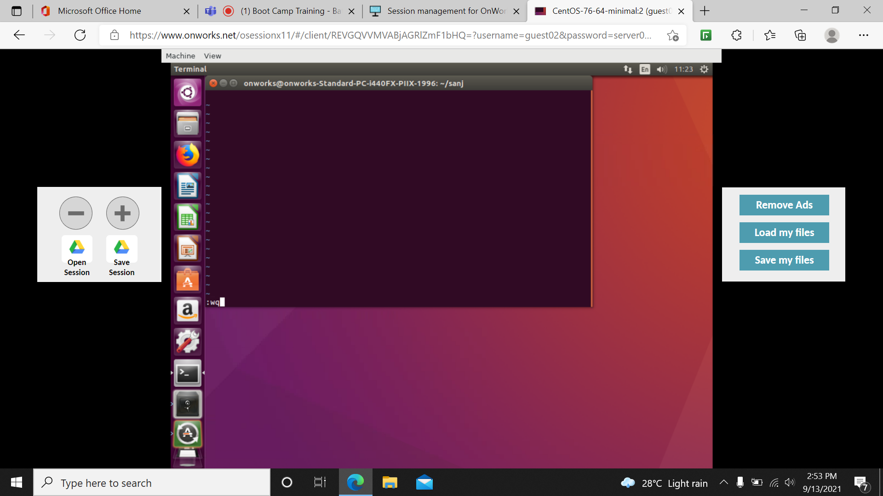

**Df**: shows the diskspace usage information.

**Df –h**: shows the diskspace usage information in gb or mb format.

**Clear**: it the will the screen.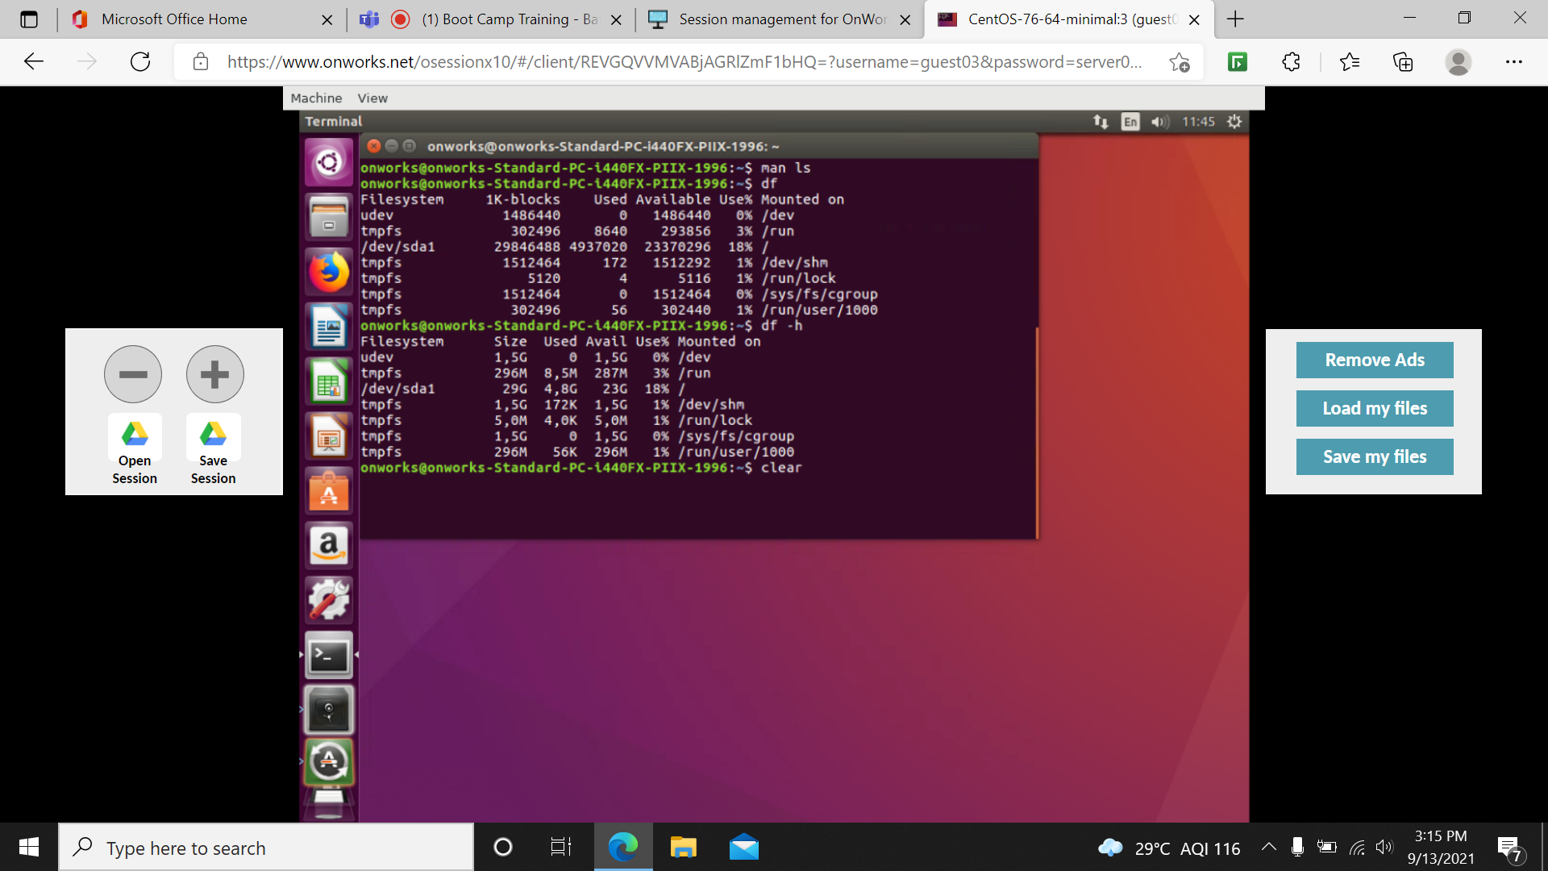

**Ps**: gives the status of current running process.

**Ps –a**: hidden process.

**Gedit**: to open the notepad terminal.

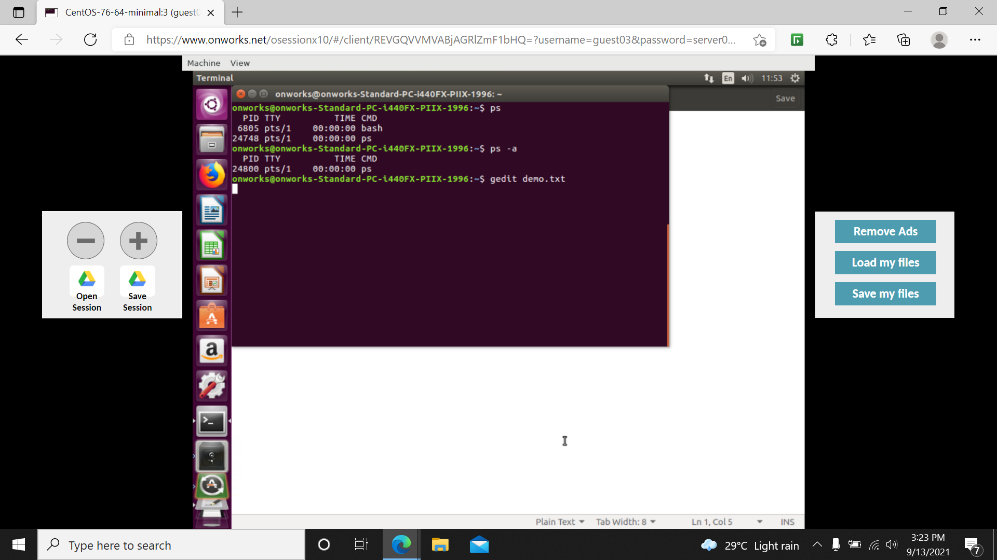

**Sudo**: superuser privileges to install/update/delete.

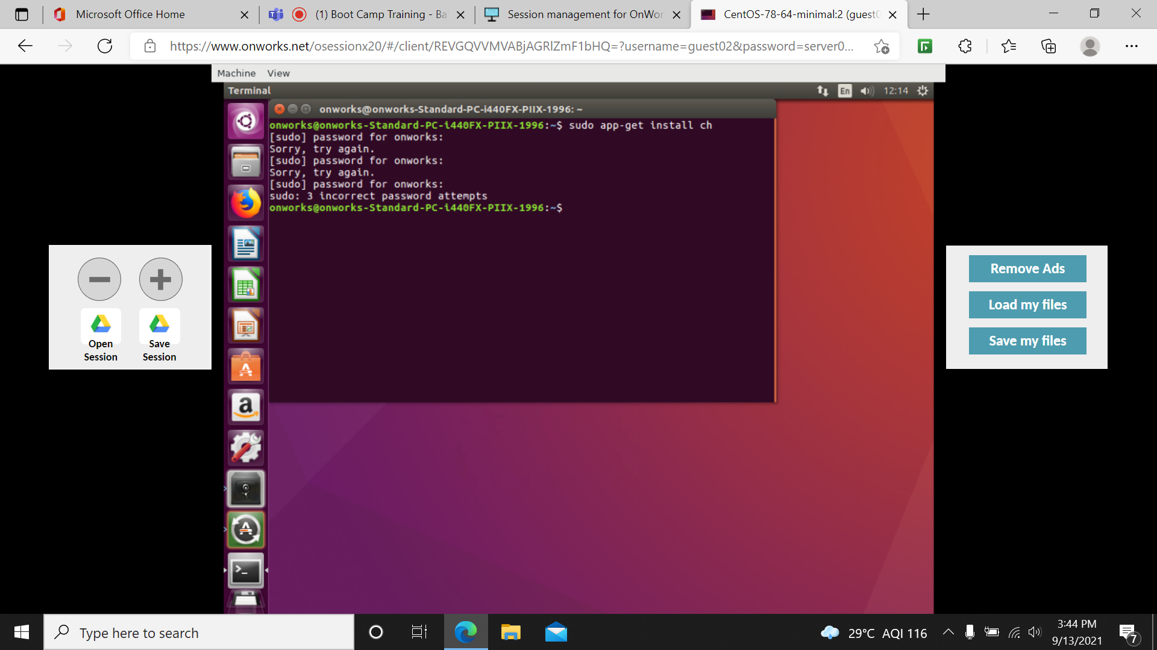

**Exit**: to exit from the terminal.

